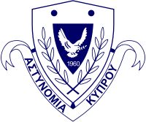
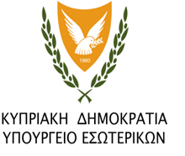
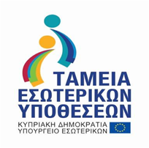
ΕΥΡΩΠΑΙΚΗ ΕΝΩΣΗ

CY/2019/ISF/SO5.NO3.1/2
Trainings for strengthening the operational capabilities of the Police for prevention and combating crime

Date of Signing of the Agreement: 02/9/2019
Project Duration: 01/01/2018 - 31/12/2021
Project budget: € 97.370

This project concerns educational programs and study visits for strengthening the operational capabilities for prevention and combating cross-border crimes, in the framework of Special Objective 5, National Objective 3 C. Specifically, trainings will be carried out on economic and cybercrime investigations, as well as on combating drugs. Police Officers will participate to these trainings and also officials from Governmental Departments, who are ivolved with these issues. In addition, study visits will take place to other Member States for the inspection and the corruption of the police officers.
Also, Cyprus Police Academy will organize training programs on combating cross-border crime refering to the Stockholm Program and the European Law Enforcement Authority (LETS) Training Program.
Police Officers of Drug Law Enforcement Unit will make study visits to airports and ports of other Member States from for the purpose of exchanging good practices for combating drugs trafficking through entry / exit points. Also, for the prevention of drug smuggling trainings will be organized in Cyprus and study visits in Greece.
Furthermore, trainings will be conducted for combating cybercrime and cyber security for judges and prosecutors explaining the basic principles of the internet and communications network. This action will be implemented in cooperation with the private sector and Eurojust. Trainings will be organized in Cyprus for Police Officers of Cybercrime Unit, regarding the collection of evidence from the crime scenes, as well as the basic principles for cybercrime investigations. Trainings on the same topics will also be organized abroad. Internal Audit Unit of the Police has been set up for the inspection and the corruption of the Police Officers. Therefore, its members will visit the similar Unit in Greece in order to be informed about the way in which this Unit works and to discuss the development of cooperation between the two sides.
The same project includes training programs in Cyprus Police Academy on Law Enforcement at European Level (LETS), in order to develop and consolidate the necessary basic knowledge and skills for all Police Ofiicers in order to establish and consolidate a common culture in Law Enforcement Authorities in the EU. The aim of these courses will be to give sufficient knowledge to Police Officers regarding the basic principles of law enforcement effective cooperation, fundamental rights, the role and function of European Organizations (Europol, Frontex, Eurojust) and the use of intelligence management tools at European level (Swedish Initiative, SIS).
Due to the COVID-19 pandemic since March 2020 until August 2021, trainings and study visits couldn’t take place.
Hopefully, some of the trainings will take place after September 2021.

The project is co-financed by 90% from the EU Internal Security Fund and by 10% from the Republic of Cyprus.

